EXHIBITION
Hermann Czech – Approximate Line of Action

Opening: 17 September 2025, 7 p.m. at HDA, Mariahilferstraße 2, 8020 Graz
Exhibition: 18 September – 12 December 2025, Tuesday–Sunday 11 a.m.–5 p.m.
Guided tours of the exhibition: Every Saturday at 3 p.m., Sunday at 11 a.m. and on request
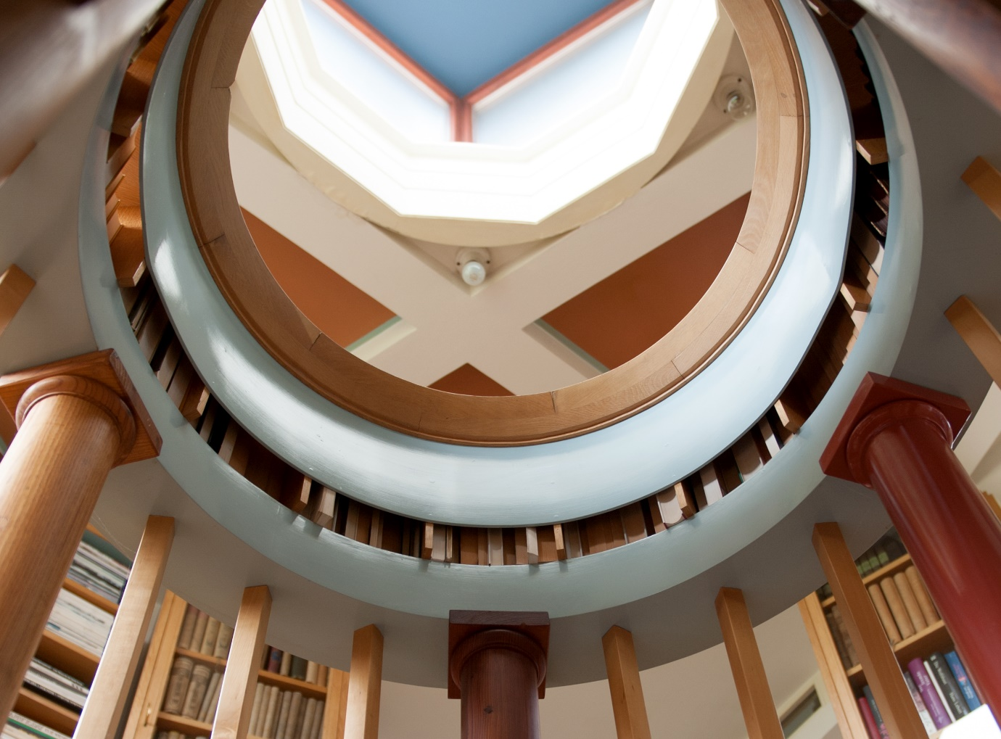
Hermann Czech, Haus S, Bibliotheksturm. Photo: Gabriele Kaiser

Hermann Czech ranks among Austria’s most renowned architects. His multifaceted work combines theory and practice, and ranges from urban planning over residential, school and hotel buildings to small-scale interventions and exhibition architecture. Czech bases his design approach on methodically developed planning decisions that simultaneously remain open to the unexpected and the everyday. The exhibition presents a selection of his work from the 1960s to the present, including theoretical projects. It also explores Czech’s critical engagement with the architectural avant-garde of the 1960s, as featured for example in the trigon exhibitions in Graz.

Hermann Czech ranks among Austria’s most renowned architects, and is a prominent voice in the current discourse. His architectural oeuvre encompasses urban planning, residential, school and hotel buildings, as well as small-scale interventions and exhibition architecture. Czech understands architectural theory as ‘thinking to the design’: his critical writings on the protagonists of Viennese Modernism, on architectural concepts such as ‘remodelling’ or on the methods of architectural production testify to a close relationship between theory and practice. Czech’s design thinking builds on the conviction that planning decisions can only prove viable if they are methodically developed rather than based on ‘inspiration’, but at the same time also remain open to the unexpected and the everyday. The exhibition ‘Hermann Czech - Approximate Main Direction’ explores this ‘multi-layered nature’ of conceptualising and implementing architectural plans in a diverse selection of projects. Using designs and completed projects from the 1960s to the present, the exhibition illustrates Czech’s methods (‘how something develops’) and spatial effects (‘how something looks’). The pointed juxtaposition of these examples reveals a richness even in inconspicuous details, and also illuminates aspects of participation, which in Czech’s case corresponds to a conceptually well-founded Mannerist stance. Czech’s architecture does not seek to seduce, but instead to convince through profound design decisions and the spatial experience itself.
The show in Graz also addresses Czech’s critical attitude towards the architectural avant-garde of the late 1960s in Austria, which Peter Cook later made internationally famous under the name ‘The Austrian Phenomenon’. The trigon architecture exhibitions in Graz in 1967 and 1969 provided an important point of crystallisation for this scene. Czech also submitted a project (‘Räumlicher Städtebau’, Spatial Urban Development) to trigon in 1969, but it was not accepted at the time. Shortly thereafter, in 1971, Czech summarised his criticism of contemporary architectural trends in his essay ‘Nur keine Panik’ (Don’t Panic). The exhibition in Graz will also include previously unpublished projects, such as his contribution to the Trigon Museum competition.

Hermann Czech (b. 1936 in Vienna) studied architecture at the Technical University of Vienna and at the Academy of Fine Arts in Vienna under Ernst A. Plischke. In 1958 and 1959 he took part in Konrad Wachsmann’s seminars at the Salzburg Summer Academy. He began designing architectural projects in 1960, and published architectural criticism in the journal Die Furche from 1963 to 1967. From the 1970s onwards, he designed and completed numerous projects at various scales. He published his early writings in 1978 under the title Zur Abwechslung (By Way of Variety, extended edition 1996), followed in 2021 by Ungefähre Hauptrichtung. Schriften und Gespräche zur Architektur (Approximate Main Direction: Writings and Conversations on Architecture), both published by Löcker Verlag. Czech has taught as a visiting professor at international and national universities, including Harvard University in Cambridge, Massachusetts , the ETH Zurich, the TU Vienna and the Academy of Fine Arts in Vienna. In 1980, 1991, 2000, 2012 and most recently in 2023 he took part in the Architecture Biennale in Venice, in 2023 in collaboration with the architectural collective AKT. He has received numerous prizes and awards for his architectural work, most recently the Grand Austrian State Prize in 2024. Czech lives and works in Vienna.

An exhibition of the fjk3 – Contemporary Art Space in cooperation with the Architekturzentrum Wien. Curators of the Exhibition ‘Hermann Czech – Approximate Line of Action’ in Vienna: Claudia Cavallar, Gabriele Kaiser, Eva Kuß and Fiona Liewehr in collaboration with Hermann Czech.

Eva Kuß and Zerina Džubur redesigned the exhibition with Hermann Czech for the HDA - Haus der Architektur. A cooperation in the context of steirischer herbst ‘25

Highlights of the exhibition ‘Hermann Czech – Approximate Main Direction’

Opening
Date: 17 September 2025, 7 pm
Location: Haus der Architektur, Mariahilferstraße 2, 8020 Graz

The opening will feature an introduction to Hermann Czech’s work and to the content of the exhibition. Czech will deliver a talk about his work and discuss the focus of the exhibition with the curators Eva Kuß and Zerina Džubur.

Exhibition tour with the steirischer herbst
Date: 27 September 2025, time to be announced
Location: Haus der Architektur, Mariahilferstraße 2, 8020 Graz
In an event organised jointly with the steirischer herbst, we will offer an in-depth examination of the content and history of the trigon exhibitions. Integrated into the accompanying programme of the steirischer herbst, the event invites visitors to an open discussion on the avant-garde, architecture and its reception with Christine Frisinghelli (former artistic director of the steirischer herbst), Eva Kuß (curator) and Zerina Džubur.

A collaboration within the framework of steirischer herbst '25

The exhibition and accompanying programme are supported by the Province of Styria, A9 – Culture, Europe and Sport

Further information is available on the HDA website:
https://hda-graz.at/programm/hermann-czech-ungefaehre-hauptrichtung

Press photos can be found at the following link:
www.hda-graz.at/pressebereich-hda/pressemappe-hermann-czech-ungefaehre-hauptrichtung

CONTACT:
Dipl.-Ing. Nelly Sanjta
Communications & Project Management
T: +43 316 32 35 00 16
E. sanjta@hda-graz.at

