EXHIBITION
Timber Architecture with PEOPLE. PLACE. HOUSE. COMMON SENSE.
Opening: 16 September 2026, 7:00 pm, HDA, Mariahilferstraße 2, 8020 Graz
Exhibition: 17 September – 20 November 2026, Tue–Sun, 11:00 am–5:00 pm
Guided Tours: Saturdays at 3:00 pm, Sundays at 11:00 am and by appointment
world_wide_wisdom: Lecture by Helen & Hard, 4 November 2026, 7:00 pm, HDA
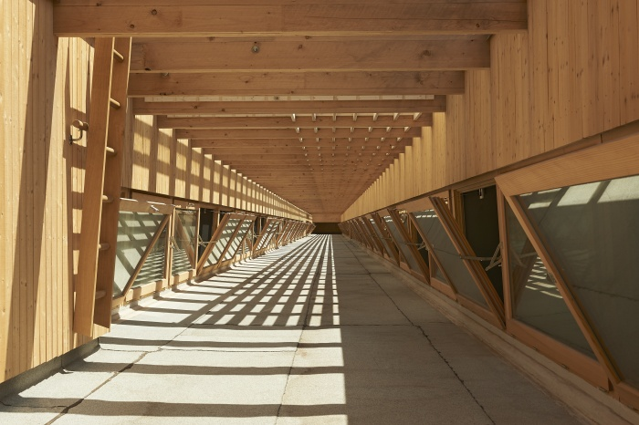
Agricultural Centre Salez – Switzerland, Andy Senn Architektur © Seraina Wirz

Timber construction plays a central role in making architecture and the building industry more sustainable. Yet simply building with timber does not automatically make a building sustainable. Through a selection of outstanding projects, the exhibition Timber Architecture with PEOPLE. PLACE. HOUSE. COMMON SENSE. explores the social, cultural, spatial and constructive qualities that make timber architecture truly fit for the future. Following its first presentation at kunsthaus muerz, the exhibition is presented at HDA – House of Architecture with a stronger focus on international projects, complemented by current research from Graz University of Technology. It offers diverse perspectives on building with timber and serves as a starting point for a broader discussion on the future of architecture.

Timber is often celebrated as the material of the construction transition due to its renewable nature and its ability to store carbon. However, sustainability requires much more than simply replacing one material with another. Based on exemplary projects, the exhibition examines the social, architectural, spatial and constructive aspects necessary to achieve genuine ecological, economic and social sustainability.

Built space—with its proportions, surfaces, transitions, sightlines and functions—always exists in relation to the people who inhabit, experience and shape it. Depending on how they are designed, buildings and their surroundings can foster identity, communication and social cohesion—or prevent them. The selected projects demonstrate socially and structurally sustainable timber architecture that revitalises village centres, responds carefully to the needs of its users and pioneers innovative construction methods. They show timber buildings that offer ecological and social value far beyond functional requirements.

Timber construction has long played a defining role in building culture. Agricultural buildings, homes and public architecture have shaped our cultural landscapes for centuries. What matters is not only whether we build, but how architecture relates to its surroundings and how it is inhabited. Contemporary timber architecture creates cultural value through the collaboration of clients, architects, engineers and craftspeople while further developing traditional building knowledge.

Resource-efficient and sufficient forms of construction are based on reduction and centuries of accumulated knowledge. Timber beams were traditionally reused across generations—a practice that has regained importance in today's circular economy. At the same time, new technologies are transforming the possibilities of joinery, disassembly and material reuse. The exhibition highlights the sustainable use of timber as a resource as well as the essential contribution of craftsmanship and research to the future of construction. It also encourages reflection on appropriate design solutions, the existing buildings of tomorrow and the social, political and ecological conditions required for the building transition.

In its second edition, the exhibition places a stronger emphasis on international projects that offer diverse responses to the challenges of building with timber. These are complemented by research projects from Graz University of Technology, showcasing current developments at the intersection of material research, structural design and construction practice. In doing so, the exhibition acknowledges Graz and the province of Styria as internationally recognised centres of timber construction, timber research and the wood-processing industry, connecting regional expertise with international perspectives.
The exhibition unfolds through four thematic layers: PEOPLE. (social and cultural aspects), PLACE. (spatial and architectural culture), HOUSE. (craftsmanship and construction), and COMMON SENSE. (ecological and economic aspects). Visitors are invited to explore these themes and discover the projects from multiple perspectives, revealing the many potentials of timber architecture.

At HDA, the exhibition is accompanied by a public programme that deepens the discussion on sustainable building through current positions in timber architecture. As part of the world_wide_wisdom lecture series, the internationally renowned architectural practice Helen & Hard will present insights into its work. The exhibition is therefore conceived not only as a presentation of exemplary architecture but also as a platform for dialogue on the future of building.

Exhibited Projects
NEW IN THE VILLAGE CENTRE. Teufenbach, Lendarchitektur (Klagenfurt) and Scheiberlammer Architekten (Wolfsberg)
INHAUSER, Salzburg, Austria – cs-architektur and stijn nagels architecture atelier (Salzburg)
AGRICULTURAL CENTRE – Salez, Switzerland, Andy Senn (St. Gallen)
MATADOR – Vaduz, Liechtenstein, Studio Saal (Feldkirch)
MACHINE HALL – Irschenhausen, Germany, Florian Nagler (Munich)
This project was submitted through the HDA Open Call 2025 and further developed in collaboration with HDA.

Commissioned by
Province of Styria, Department 16 – Transport and State Building Construction, and kunsthaus muerz.
Curators
Eva Hierzer, NOW Architektur
Tom Kaden, Chair of Architecture and Timber Construction
Zerina Džubur, HDA – House of Architecture
Exhibition Design
Studio Magic & NOW Architektur, based on a concept developed by students of the Faculty of Architecture at Graz University of Technology.
The exhibition design illustrates the principles of circular construction.
The concept for the easily demountable exhibition system was developed by Frederik Baldasty, Marius Birnbreier, Jonas Flache, Maximilian Huß-Galli and Melina Sehn as part of Workshop 3 under the supervision of Tom Kaden, based on the exhibition concept, and further developed for implementation by Studio Magic.
The exhibition was first presented at kunsthaus muerz in 2024.

Public Programme
Opening
Wednesday, 16 September 2026, 7:00 pm
HDA – House of Architecture, Graz
Curator's Tour (as part of steirischer herbst)
Saturday, 3 October 2026, 11:00 am
As every year, HDA offers an exclusive curator-led tour of its current exhibition as part of the steirischer herbst festival (24 September–18 October 2026).
world_wide_wisdom with Helen & Hard
Wednesday, 4 November 2026, 7:00 pm
Founded in Stavanger in 1996 by the Norwegian architect Siv Helene Stangeland and the Austrian architect Reinhard Kropf, Helen & Hard today comprises 26 architects from ten different countries, working from offices in Stavanger and Oslo. Over the past decades, the practice has become internationally recognised for its pioneering timber architecture, much of it realised in collaboration with Swiss engineer Hermann Blumer. Their projects include the Norwegian Pavilion at Expo 2010 in Shanghai and the award-winning public library in Grimstad, completed in 2017, which ingeniously transforms the concrete structure of a former police station into a contemporary timber building.
Finissage
Friday, 20 November 2026, 7:00 pm

Further Information
https://hda-graz.at/programm/holzbau-architektur-mit-mensch-ort-haus-verstand
Press Images
https://hda-graz.at/pressebereich-hda/pressemappe-holzbau-architektur-mit-mensch-ort-haus-verstand

Contact
Nelly Sanjta
Communication, Architecture Mediation & EU Projects
T +43 316 32 35 00 16
E sanjta@hda-graz.at

