PRESS INFORMATION



Sorry, the file you have requested
does not exist.

Liebe Grüße aus Graz von Superstudio

Exhibition

In the context of steirischer herbst '19 and Future Architecture Platform

Haus der Architektur | House of Architecture, September 2019
Ausstellung

Title | Sorry, the file you have requested does not exist.  Liebe Grüße aus Graz von Superstudio
Dates | Exhibition press preview: 20.09.2019, 10 am,  please register under presse@hda-graz.at  Artist Talk: 20.09.2019., 5 pm  Exhibition opening: 21.09.2019, 1:30 pm  as part of the openings of steirischer herbst '19  Duration of the exhibition: 21.09.-08.11.2019,  Tue-Sun 10 am – 6 pm
Venue | Haus der Architektur | House of Architecture (HDA)  Mariahilferstraße 2, 8020 Graz, Austria
About the exhibition | The radical conceptual approach of Superstudio, a group of architects and artists that formed in Florence in 1966, made 20th-century architecture history with the design proposal "The Continuous Monument: An Architectural Model for Total Urbanization" (1969). The first and only constructed version of this design was realized in 1969 in Graz as part of the three-country biennial "trigon 69: architektur und freiheit".  Fifty years after Superstudio responded to the zeitgeist of the 1960s with a criticism of the notions of progress that defined the era, artists and architects of a younger generation now examine the social conditions that accompanied the production and reception of Superstudio’s ideas. Influenced by digital image production, they have developed an immersive environment for the exhibition "Sorry, the file you have requested does not exist. Liebe Grüße aus Graz von Superstudio", which examines the role of architects as space designers and explores the future potential of architectural tools. The presented positions address the increasing visualization of the present, questioning not just reality but also the agents that refer to this reality.
Verantwortliche | Curated by Ludwig Engel, BB Mak  Artists: (ab)normal, Hironaka & Suib, Robin Klengel/Leonhard Müllner, Lion & Unicorn, Vojtěch Rada, Stéphanie Roland, Bernd Trasberger and Superstudio  Scenography: Traumnovelle  Design: Julia Volkmar  Program coordination: Markus Bogensberger, Zerina Džubur
Organizer | Haus der Architektur | House of Architecture (HDA)
Sponsors/Partners | The exhibition takes place as part of steirischer herbst'19 and  Future Architecture Platform  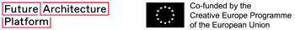  In cooperation with Neue Galerie Graz / Universalmuseum Joanneum  With the kind support of the Italian Cultural Institute in Vienna  Supported by Eternit Österreich GmbH and steirischer herbst '19
Participating artists and architects | (ab)Normal  Founded 2018 in Rotterdam  Marcello Carpino *1994 in Syracuse, lives and works in Rotterdam  Mattia Inselvini *1992 in Brescia, lives and works in Rotterdam  Davide Masserini *1993 in Bergamo, lives and works in Rotterdam  Luigi Savio *1987 in Florence, lives and works in Milan  (ab)Normal was founded in 2018 while working together at OMA in Rotterdam. Recent projects include Everyday Ruins (Balts Projects, Zurich), Microtools (Alcova, Milan), Datasutra (Anise Gallery, London). Among others, their work has been exhibited in Dichtelust (SAM, Basel), Relics (Salone Internazionale del Mobile, Milan) and Wide Art (Affordable Art Fair, Milan).  Hironaka & Suib  Founded 2008 in Philadelphia  Nadia Hironaka * 1975 in Montréal, Canada, lives and works in Philadelphia  Matthew Suib * 1973 in Little Rock, Arkansas, lives and works in Philadelphia  The Philadelphia-based artists Nadia Hironaka and Matthew Suib collaborate together since 2008. In their work they employ the tools and conventions of moving-image culture to offer counter-mythical visions of our contemporary world. In doing so they re-construct existing narratives and envision new images that challenge popular understandings of history and culture. Hironaka & Suib are recipients of several awards including the Guggenheim Foundation Fellowship, Pew Fellowships in the Arts and Fellowships from CFEVA and Pennsylvania Council on the Arts. Their work has been widely exhibited both domestically and abroad at venues including MAXXI (Rome), New Media Gallery (Vancouver), The Institute of Contemporary Art (Philadelphia), UCLA Hammer Museum, PS1/MoMA and Philadelphia Museum of Art. Matthew Suib is co-founder of Greenhouse Media and Nadia Hironaka serves as a professor and department chair of film and video at the Maryland Institute College of Art.  Robin Klengel / Leonhard Müllner  Robin Klengel *1988 in Graz, Austria, lives and works in Graz/Vienna  Leonhard Müllner *1987 in Graz, Austria, lives and works in Vienna  Robin Klengel’s and Leonhard Müllner’s artistic practice is focused on questions of individual and collective possibilities to question, critically interact with or subvert given spatial settings. Their film Operation Jane Walk has been shown at IDFA Amsterdam, BFI London Film Festival, Ars Electronica Animation and IndieLisboa amongst others, was awarded „Best Austrian Film“ at Vienna Short Film Festival and won the “Audience Award” at Shortwaves – International Film Festival Poznan.  Lion & Unicorn  The independent group consists of the architect Maria Kachalova and six graduates of the Moscow Strelka Institute for Media, Architecture and Design - Liza Dorrer, Karina Golubenko, Pekka Airaxin, Maria Kosareva, Ivan Kuryachiy and Anton Kalgaev. Kalgaev was also one of the curators of the official Russian Pavilion at the Venice Architecture Biennale in 2014. The group logo comes from the two symbols that the architect Alexei Shchusev erected in 1914 at the gates of the Russian pavilion.  Vojtěch Rada  * 1991 in Prague, lives and works in Prague  Vojtěch Rada creates environments reflecting his extensive artistic education: he studied at the Department of Architecture (the Academy of Arts, Architecture and Design; and the Academy of Fine Arts, both in Prague), the Department of Sculpture (the Academy of Arts, Architecture and Design) and the Department of Game Design (Zurich University of the Arts). He combines all the disciplines in his artistic practice. Since 2013, Rada participates in international exhibitions, amongst others Ars Electronica (Linz) and Academiae Biennial 2018 (Franzensfeste, Italy) curated by Christian Jankowski.  Stéphanie Roland  * 1984 in Brussels, lives and works in Brussels  Graduated from La Cambre, Brussels, and UDK Berlin (class Hito Steyerl), Stéphanie Roland is a multidisciplinary visual artist who regularly gives talks about her practice; among others, she was TEDx Brussels speaker in 2018. Roland’s work has been shown at the Louvre Museum (Paris), Benaki Museum (Athens), Botanique (Brussels), Kampala International Art Biennale and Bozar (Brussels). Breda Photo, Belfast Photo festival, Manifesto (Toulouse), Encontros da Imagem (Braga), BIP Liège, MOPLA (Los Angeles) and Unseen (Amsterdam) are amongst the festivals dedicated to Photography in which she took part. Roland won a number of prizes and was notably shortlisted for the HSBC Photography Award and the Leica Oskar Barnack Award. In 2017, she participated in the group exhibition Antarctica of the Antarctica Pavilion at the 57th Venice Biennale. In 2019 she has been selected to show her films at Rencontres Internationales Paris/Berlin.  Bernd Trasberger  * 1974 in Mönchengladbach, lives and works in Berlin  In his sculptural work, installations, collages and research-based works, Bernd Trasberger investigates moments of change in the urban realm. Post-war modern utopias are a major reference point. Trasberger studied at Gerrit Rietveld Academie in Amsterdam, Netherlands, and at Hochschule für Bildende Künste in Brunswick, Germany. His works have been exhibited in numerous international galleries and institutions, amongst them Galerie der HGB Leipzig, NGBK Berlin, Berlinische Galerie – Museum für Moderne Kunst, W139 (Amsterdam), Artisterium (Tbilissi), International Biennale for Contemporary Art Baku, Thyssen-Bornemisza Art Contemporary 21 (Vienna) und Museum Abteiberg (Mönchengladbach). Trasberger is the recipient of the renowned Pollock-Krasner-Foundation Grant 2019.  Traumnovelle  Founded 2015 in Brussels  Léone Drapeaud *1987 in Canberra, lives and works in Paris  Manuel León Fanjul *1990 in Charleroi, lives and works in Brussels  Johnny Leya, *1990 in Kinshasa, lives and works in Paris  Traumnovelle is a self-proclaimed “militant fraction” working at the fringes of spatial practice through merging fiction and architecture as critical and subversive tools. Traumnovelle were the commissioned curators for the Belgian contribution to the Venice Architectural Biennale in 2018. They have been lecturing in Brussels, Paris, Marseille, Rotterdam, Kiev, Ljubljana. They are working internationally on different scales ranging from reconversions of industrial buildings to paper architecture. Their work has been published in Site Magazine, l'Architecture d’aujourd’hui, A+, Architectural Digest and Cosa Mentale amongst others.
Scenography of  the exhibition | Traumnovelle  Congregation of the Machines is a contemporary reinterpretation of the spatial scenography at Künstlerhaus Graz for the exhibition Trigon ’69 – Architecture and Freedom 1969. It draws upon the reference to a TV studio’s “Green Screen”, which is both a spaceless space and the possibility of all spaces. It interrogates the endless repetition of space perceptible in Superstudio’s The Continuous Monument, which found its first (an only) materialization on the occasion of the Trigon ‘69.  Traumnovelle  Congregation of the Machines, 2019  Chromagreen emulsion paint, chromagreen vinyl floor, drywall, 8 flatscreens, 12 headphones, synchronizer, cables  2128 x 473 x 240 cm
Video works | (ab)Normal  Inspired by a passage from Italo Calvino’s Invisible Cities (1972), (ab)Normal creates a speculative future city as imagined by a sleeping android. In a short break from work the android follows his memories back to the fantastic city of Antea—ever present and forever out of reach. (ab)Normal’s visual worlds cite their work as architects with 3D computer graphics programs. In their works they illustrate not only how dreams made by machines for machines could look like but also confront us with the question for whom virtual worlds are designed for in the first place.  (ab)Normal  Antea, 2019  Full HD video, color, sound  1’13”  Bernd Trasberger  Through an extensive research into Superstudio’s competition entry to the tri-national biennial Trigon ’69, Bernd Trasberger developed a new video work, in which historical documents and works from the archives of Neue Galerie and steirischer herbst are contrasted with contemporary quotes and reflections on the legacy of Superstudio today. For the multi-channel video installation at Haus der Architektur, Trasberger’s video Liebe Gruesse aus Graz von Superstudio (2019)—a single-shot scene—is presented in three chapters: Superstudio, Il Monumento Continuo und La Stanza di Graz.  Bernd Trasberger  Superstudio (from Liebe Gruesse aus Graz von Superstudio), 2019  Full HD video, color, sound  4’57”  Bernd Trasberger  Il Monumento Continuo (from Liebe Gruesse aus Graz von Superstudio), 2019  Full HD video, color, sound  10’24”  Bernd Trasberger  La Stanza di Graz (from Liebe Gruesse aus Graz von Superstudio), 2019  Full HD video, color, sound  8’21”  Hironaka & Suib  At HDA Graz Hironaka & Suib present a sequence from their video work The Continuous Moment, Part 1 (2014)—a speculative history, in which Superstudio’s Continuous Monument has been realized. Make-believer (2019) is a reenactment of Superstudio’s famous collage Fundamental Acts. Vita–Supersuperficie. Spring cleaning (1971), showing the very first maintenance measure for the Continuous Monument. While in Superstudio’s collage the leftover of the world is represented by a site of decay and ruin, Hironaka & Suib’s opening in the overall grid depicts the surface as a place for leisure activities.  Hironaka & Suib  Make-believer (from The Continuous Moment, Part 1), 2014/2019  HD video  continuous loop  Robin Klengel / Leonhard Müllner  Operation Jane Walk (2018) is based on the dystopian multiplayer shooter Tom Clancy’s: The Division (2016). In this work, the game’s digital war zone is appropriated with the help of an artistic intervention. Within the rules of the game’s software, the militaristic environment is being re-used for a pacifistic city tour. The urban flâneurs avoid the combats whenever possible and become peaceful tourists of a digital world, which is a detailed replica of the real world. The video documents a live performance lecture, which deals with architecture history, urbanism and the game developer’s interventions into the urban fabric of New York.  Robin Klengel & Leonhard Müllner  Operation Jane Walk, 2018  Full HD video, color, sound  16’14”  Stéphanie Roland  In her work Phantom Islands (2019) Roland explores the underlying narratives that shape our perception of reality in the post-digital age referring to Superstudio’s The Continuous Monument (1969) that anticipated virtual infinity and contemporary digital mapping. As single total environment The Continuous Monument predicted a uniform world rendered by technology, culture and imperialism. For Sorry, the file you have requested does not exist. Roland has developed fictive Google Earth satellite views featuring historical phantom islands, that once had been mapped or described in historical documents but whose existence had otherwise never been proven.  Stéphanie Roland  Phantom Islands (Estotiland), 2019  Full HD video, multi-channel installation, b/w, sound  3’  Stéphanie Roland  Phantom Islands (Pontchartrain), 2019  Full HD video, multi-channel installation, b/w, sound  3’  Stéphanie Roland  Phantom Islands (Rupes Nigra), 2019  Full HD video, multi-channel installation, b/w, sound  3’  Vojtěch Rada  Song for the Deaf (2019) is a 3D-animation that addresses the present and possible future of the architect and the function of architecture channeled through technological tools. In a virtual monologue, computer generated avatars reflect on space, time, processes and algorithms. Following a quote by Adolfo Natalini, co-founder of Superstudio, Vojtěch Rada applied the concept of the “digital ruin” to the work of Superstudio: „Ruins and projects have a point of similarity. They share the sad destiny of absence: in the former case, it is the absence of something that no longer exists; in the latter case it is the absence of something that does not yet exist. (…) In some cases, architecture discovers metabolic opportunities in ruins.“ (Natalini, 2013)  Vojtěch Rada  Song for the Deaf, 2019  Full HD video, color, sound  14’15“
Future Architecture Platform | The House of Architecture is part of the Future Architecture Platform, founded in 2015 – the first pan-European platform for architecture institutions, festivals and producers. The focus is visions for the future of architecture in Europe. After an annual open call with young creatives from various disciplines, 23 institutions from 20 countries present an individual event program consisting of exhibitions, conferences, lectures, workshops and much more.  Five of the emerging artists and architects represented in the exhibition were chosen from the Future Architecture Open Call submitters in 2019.  Here you can get an impression of the activities of the House of Architecture in the context of Future Architecture Platform over the last years: https://hda-graz.at/projekte/future-architecture-platform-en
Event on HDA website | https://hda-graz.at/programm/sorry-the-file-you-have-requested-does-not-exist-en
Press information and pictures for download | On our website you can download press information and high resolution pictures under the following link: https://hda-graz.at/pressebereich-hda/pressemappe-sorry-the-file-you-have-requested-does-not-exist

Press images + credits | 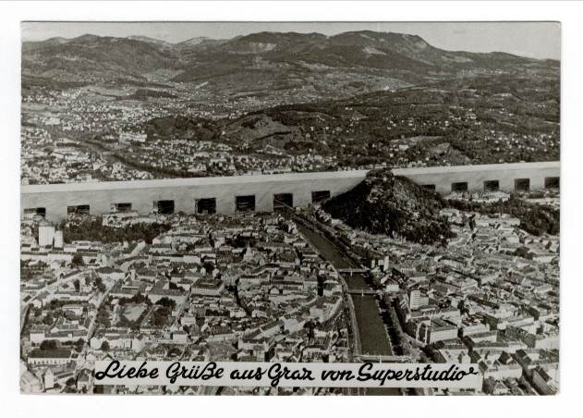  Superstudio, „Liebe Grüße aus Graz von Superstudio“ (Ansichtskarte), 1969  © Superstudio, courtesy Privatsammlung, Berlin  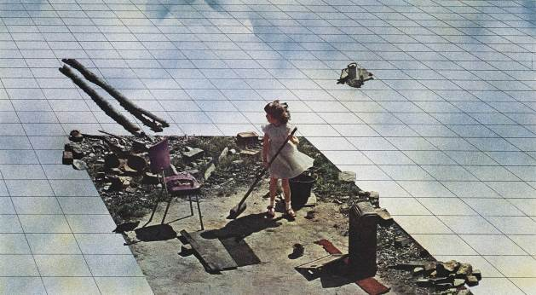  Superstudio, Atti Fondamentali. Vita – Supersuperficie. Pulizie di primavera, 1971. Lithograph. Detail. © MAXXI National museum of 21st century arts, Rome. MAXXI Architettura Collection, Superstudio fund  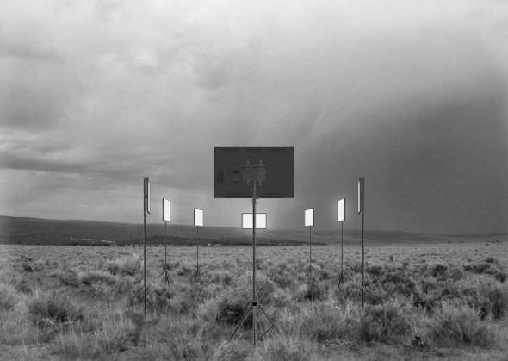  Traumnovelle, Congregation of the Machines, 2019, digital concept collage © Traumnovelle, 2019, courtesy by the artists  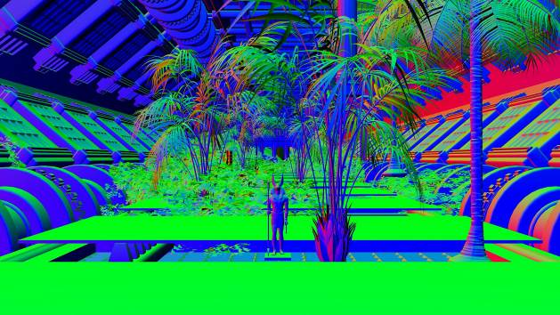  (ab)Normal, Antea (still), 2019, Full HD video, color, sound, 1’13” © (ab)Normal, 2019, courtesy by the artists  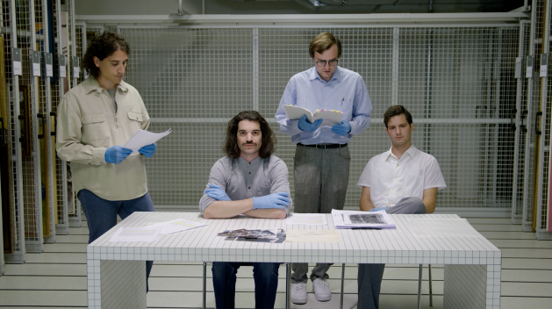  Bernd Trasberger, Superstudio (from Liebe Gruesse aus Graz von Superstudio) (still), 2019, Full HD video, color, sound, 4’57” © Bernd Trasberger, 2019, courtesy by the artist  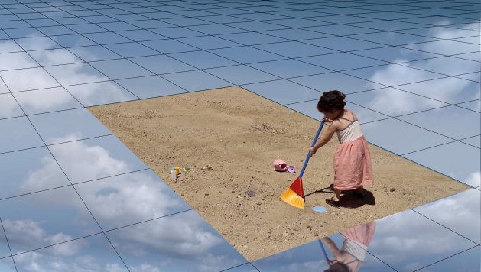  Hironaka & Suib, Make-believer (from The Continuous Moment, Part 1) (still), 2014/2019, HD video, continuous loop © Hironaka & Suib, 2019, courtesy by the artists  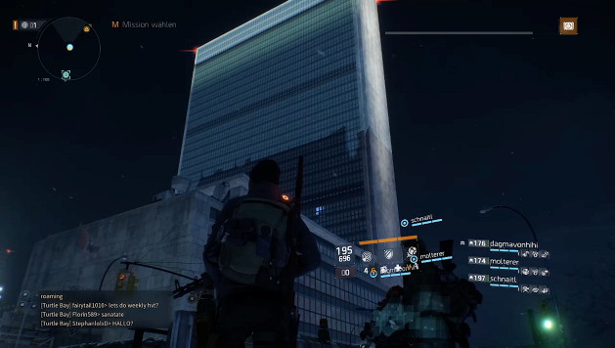  Robin Klengel & Leonhard Müllner, Operation Jane Walk (still), 2018, Full HD video, color, sound, 16’14” © Robin Klengel & Leonhard Müllner, 2019, courtesy by the artists  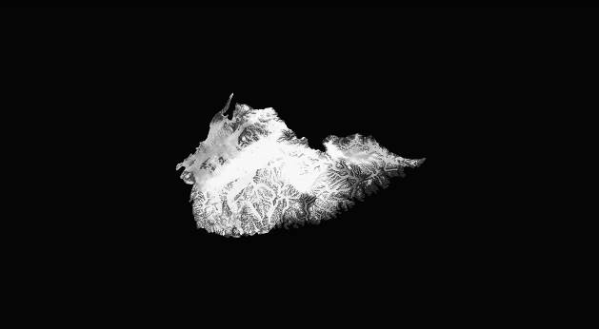  Stéphanie Roland, Phantom Islands (Estotiland) (still), 2019, Full HD video, multi-channel installation, b/w, sound, 3’ © Stéphanie Roland, 2019, courtesy by the artist  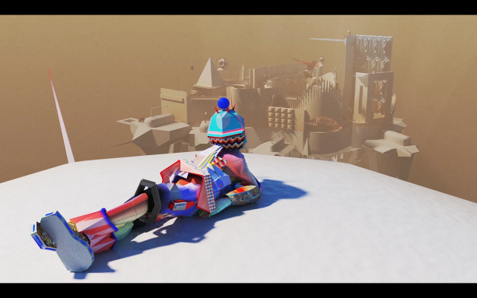  Vojtěch Rada, Song for the Deaf (still), 2019, Full HD video, color, sound, 14’15“© Vojtěch Rada, 2019, courtesy by the artist
Press contact | Yvonne Bormes  Haus der Architektur | House of Architecture (HDA)  Mariahilferstraße 2, 8020 Graz, Austria  +43 316 323500-16  presse@hda-graz.at

